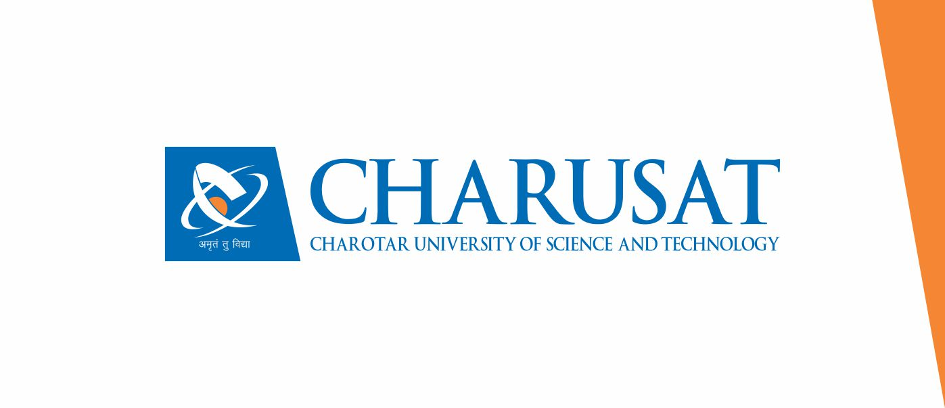

**Faculty of Management Studies (FMS)**

**Humanities and Social Sciences (HSS)**

**Assignments**

As a partial fulfillment of

Contributor Personality Development

for

6thSemester

**Instructions for Assignments writing:**

* **Font Type should be ‘Times New Roman’.**
* **Font Size should be of ‘12’.**
* **‘Justify’ the text for proper aligning**
* **Avoid Plagiarism**
* **Rename the word file with your ‘Id.No.’ and ‘Name.’**
* **E-mail the assignment file on allotted e-mail id. for your branch.**

**Assignment- Prepare a Success Story of Contributor Personality allocated to you. (Minimum 1000 Words)**

**Include the points mentioned below:**

* **Introduction**
* **Early Struggle & Success**
* **Traits of his/her personality**
* **Contribution to the society through Innovation, Products, Services, and charitable work**
* **Source of Motivation for others| My learning**

|  |
| --- |
| TATA Group - Founded by Jamsetji Tata in 1868, the Tata group maybeaglobal enterprise, headquartered in India, comprising 30 companies across ten verticals. The group operates inadditionalthan 100 countries across six continents, with a mission 'To improve thestandardof lifetimeofthe communities we serve globally, through long-term stakeholder value creation based on Leadership with Trust’. Tata Sons isthattheprincipal investment companyand promoter of Tata companies. Sixty-six percent of the equity share capital of Tata Sons is held by philanthropic trusts, which support education, health, livelihood generation and art and culture. In 2019-20, the revenue of Tata companies, taken together, was $106 billion (INR 7.5 trillion). These companies collectively employ over 750,000 people.  In 1870 with INR 21,000 capital, Jamsetji Tata founded an exchanging organization. He purchased a bankrupt oil plant at Chinchpokli and transformed it into a **cotton**under the name Alexandra Mill which he sold for a profit after 2 years. In 1874, he foundoutanother cotton factory at Nagpur named Empress Mill. His aim was to accomplish 4 main objectives: setting up an iron & steel organization, an exceptional inn, a world-class learning establishment, and a hydro-electric plant. During his lifetime, the Taj Mahal Hotel at Colaba waterfront was opened in 1903, making it the first inn with power in quite a while.  After Jamsetji's passing, Dorabji Tata, his son, became the Chairman in 1904. Sir Dorabji built up the Tata Iron and Steel organization (TISCO), presently referredtoasTata Steel, in 1907. Denoting the gathering's worldwide aspirations, Tata Limited opened its first overseas office in London. Soon as per Jamsetiji's wish, Western India's first hydro plant was set-up andthereforetheIndian Institute of Science was also foundoutin 1911. JRD Tata was crowned Chairman of Tata Group in 1938. Under his chairmanship, theadvantagesof the Tata Group developed from $100 million to over $5 billion. When he took over TATA, it had 14 undertakings, but in 1988 Tata Sons had developed to amixtureof 95 endeavors. These endeavors comprised adventures that the organization had either begun or held controlling interests in.  In 1952, JRD established an airlines, referredto **as**Tata Air Services (later renamed Tata Airlines). In 1953, the Government of India passed the Air Corporations Act and acquired a larger part stake in the transporter from Tata Sons; however, JRD Tata would continue as Chairman till 1977. In 1945, Tata Motors was established and was first centered around trains. In 1954, it entered the business vehicle showcase withinthewake of shaping a joint endeavor with Daimler-Benz. In 1968, Tata Consultancy Services was established. In 1991, Ratan Tata was crowned Chairman of Tata Group. This was additionally the time ofmonetaryadvancement in India, opening up the market to remote contenders. During this time, Tata Group started to obtain various organizations like Tetley (2000), Corus Group (2007), and Jaguar & Land Rover (2008). In 2017, Natarajan Chandrasekaran was named administrator.  In its early years, thecorporateexpanded mostly organically, resulting from industrial growth in India that didn'trequire partnerships with foreign firms. Emerging innovations, technology improvements, and creativity becameabiggrowth of the Tata Group. The Tata Group worked duringabigvarietyof industries from the capital, infrastructure, energy, capital goods, chemicals, IT, and services. Such industries rendered outstanding domestic and foreign contributions to the Group ‘s income. The Tata Group acquisition of the UK-based Tetley group perfectly illustrated it in 2000. Tata Group collaborated with American International Group, Inc. (AIG) in 2001 with the establishment of the Tata-AIG insurance provider. The Company then made a variety of purchases. Tata Steel purchased Corus3 in 2007, Tata Motors bought Jaguar and Land Rover4 in 2008, among the prominent acquisitions. Analysts acknowledgedthat although sales grew duetoinorganic expansion, it had to dealwithintegration problems and careful management of the Company’s assets. The telecommunications subsidiary of the group, Tata Communications, revealed in March 2012 its intention to buy Cable and Wireless Worldwide Plc, the the UK-based telecommunications firm. The transaction was needed toreinforceTata Communications’s role as **a** numberonesupplier of underwater fiber optics and financial services. The growth of the Tata Company was partly attributed to its foreign investments, as market analysts thought the business had posted US$48.3 billion in international turnover for the Financial Year ended in 2011. After expanding its integrity, thecorporatemade avarietyof acquisitions, whether it resulted from organic or inorganic growth strategies. It was all the vision Mr. Ratan Tata had to develop at the Tata Group duringahighly innovative way. According to him, by creativity and reasonable prices, the Company shall differentiate from most other firms. It’s not wrong toformmoney, but it'sto be handled ethically, tells Ratan Tata.  The five core Tata values underpinning the way group do business are:  Integrity- Fair, honest, transparent and ethical in their conduct; everything theyaredoingmust stand the test of public scrutiny.  Responsibility- Integrate environmental and social principles in theur businesses, ensuring that what comes from the people goes back to the people many times over.  Excellence- hookedintoachieving theverybeststandards of quality, always promoting meritocracy.  Pioneering- Bold and agile, courageously takingoverchallenges, using deep customer insight to develop innovative solutions.  Unity- Invest in people and partners, enable continuous learning, and build caring and collaborative relationships supportedtrust and mutual respect.  Tata Group love for children’s and the nation always motivates to bring life in the work we do under the group and update ourselves. In For the Love of India, R.M. Lala has drawn upon fresh material from the India Office Library in London and other archives, as also Jamsetji's letters, to portray the man and his age. It is an absorbing account that makes clear how remarkable Jamsetji's achievement truly was, and why, even now, one hundred years after his death, he seems like a man well ahead of the times. |